POS SYSTEM – MASTER PLAN

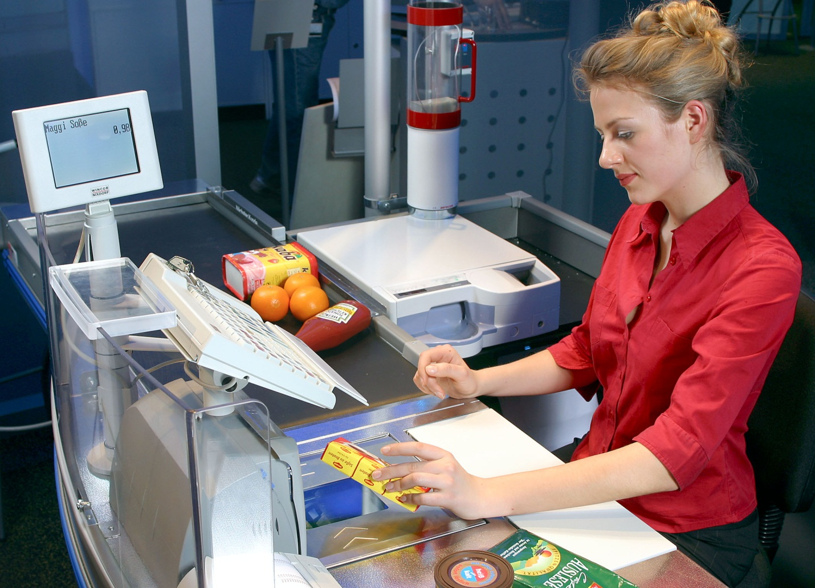

HIT Team

Consulting

Sales

Staffing

Support

**Information of document**

|  |  |
| --- | --- |
| Title | Architecture Document |
| Author(s) | All team |
| Reviewer(s) | All team |
| Team name | HIT Team |
| Team members | Thanh Giang, Hiep Ta, Phuc Nguyen, Giang Nguyen, Dat Tran, Huy Huynh |
| Project mentors | Ms. Huong Nguyen, Mr. Huyen Pham |
| Editor | Hiep Ta |
| Type of report | Architecture Document |
| Software used | MS Word, MS Excel |

**Document Reviewer Information**

|  |  |  |
| --- | --- | --- |
| Reviewer Name | Review Attendance (R/S) | Comments |
|  |  |  |
|  |  |  |
|  |  |  |
| R/S: Required or Suggested participants or functions for the document review meeting | | |

**Document Approver Information**

|  |  |  |
| --- | --- | --- |
| Approver Name | Approver Function | Comments |
|  |  |  |
|  |  |  |
|  |  |  |

**Document Revision History**

|  |  |  |  |
| --- | --- | --- | --- |
| Revision Number | Date of Issue | Author(s) | Brief Description of Change |
| 1.1 | 11/06/2012 | Thanh Giang | Create Master Plan |
| 1.2 | 11/06/2012 | Dat Tran, Phuc Nguyen, Thanh Giang, Hiep Ta | Initial Architectural Driver |
| 1.3 | 12/06/2012 | Thanh Giang, Hiep Ta | Define Scope |
| 1.4 | 14/06/2012 | Hiep Ta, Thanh Giang | Update Architectural Driver |
| 1.5 | 18/06/2012 | Hiep Ta | Edit roles and responsibilities |
| 1.6 | 23/06/2012 | Huy Huynh | Initial architecture design |
| 1.7 | 25/06/2012 | Huy Huynh, Giang Nguyen | Update architecture design |

Contents

1. Introduction 4

1.1. Overview 4

1.2. Project summary 4

1.3. Scope and objectives 4

1.4. Project Deliverables 4

1.5. Reference materials 5

1.6. Definitions and acronyms 5

2. Project organization 6

2.1. Organizational structure 6

2.2. Organizational Boundaries and Interfaces 6

2.3. Roles and responsibilities 6

3. Managerial process 8

3.1. Assumptions, dependencies, and constraints 8

3.1.1. Assumptions 8

3.1.2. Constraints 8

3.2. Risk management 9

3.3. Communication Plan 9

4. Methods, tools, and techniques 10

5. Work packages, schedule, and budget 11

5.1. Work packages 11

5.2. Schedule 11

# Introduction

## Overview

This section of the Software Project Management Plan (SPMP) gives an overview of the purpose, scope, and objectives of the project. It also contains the assumptions and constraints, the project deliverables, the summary of the schedule and budget.

## Project summary

Company A, a retail chain, has decided to develop a sales system (hereinafter, the system) in conjunction with its launch of a point service. Company A decided to choose the Web solution using ASP.NET MVC 3 framework, only Web browser, no local Database needed for any POS terminal. And authorized managers can display statistic reports from Internet.



## Scope and objectives

HIT Team will develop POS System on web platform with following targets:

* Quick Checkout: Each cashier will have a bar-code scanners. Products sold at stores have bar codes attached which indicate the product codes.
* Payment Options: Company A offers payment by cash or by using loyalty point.
* Control: Products are classified into product types such as food, general merchandise, etc. Not all stores carry every product type, and the range of product types carried is designated for each store.
* Competitive prices: the system has capable of performing the statistical analysis on the sales records of all stores in near real-time manner.
* Track product popularity and profitability.
* Improve customer throughput with faster service.
* Accelerate inventory turnover by being able to stock the items known to sell quickly.

## Project Deliverables

* Architecture drivers document
* Function requirements
* Quality attributes - most important and difficult
* Technical constrains
* Business constrains
* POS Architecture document
* Module View
* C&C View
* Allocation View

## Reference materials

* Project Plan Outline IEEE Template
* Anthony J. Lattanze, 2008, Architecting Software Intensive Systems

## Definitions and acronyms

|  |  |
| --- | --- |
| Acronym | Definition |
| IEEE | Institute of Electrical and Electronics Engineers |
| CCB | Configuration Control Board |
| CM | Configuration Management |
| C&C | Component and Connector |
| DB | Database |
| POS | Point of Sale |
| LOC | Line of Code |
| OS | Operating System |
| SPMP | Software Project Management Plan |
| QA | Quality Assurance |
| SPMP | Software Project Management Plan |
| SRE | Software Risk Evaluation |
| SRS | Software Requirements Specification |
| TSP | Team Software Process for Education |

# Project organization

## Organizational structure

This section of the SPMP identifies the external entities structure to the project and their interaction with the project team and gives a brief description of each of the roles held by the team members, as well as internal project structure and roles and responsibilities for the project.



All members have specified areas of responsibility and everybody contributes equally to the project. There are six roles assigned to the six team members: Project Leader, Architect Manager, Recorder, Planning Manager, and Support Manager.

All team members may provide input to all decisions that the team makes; however, greater weight will be given to the recommendations of the appropriate manager. If there is a problem, issues will be resolved within the team and all members will approve the final decision. The team members will change roles throughout the life of the project, and each member may continue to have more than one role.

## Organizational Boundaries and Interfaces

The team will meet weekly with the client (is also the lecturer) to report progress and discuss changes and progress possible and discuss possible changes and amendments. Major changes will affect the important events or major changes will affect important events must be approved by the whole team. From these documents it will be important issues are all members agree.

## Roles and responsibilities

|  |  |
| --- | --- |
| Roles | Responsibilities |
| Managing engineer  (Thanh Giang) | * Coordinating the overall system design and development effort. * Responsible for the success (or failure) of the design team * Listen to other members of the design team * Plan, coordinate, track, and direct the overall activities of the design team * Creating and maintaining the programmatic plans and schedules in both the period of uncertainty and the period of certainty |
| Support engineer  (Phuc Nguyen) | * Setting up and maintaining the design team’s support tools and environments * Responsible for the system or product infrastructure or environment * Play a key role in the design of the system from a physical perspective |
| Chief architect  (Huy Huynh) | * Responsible for overall system design * Work with all of the other members of the design team to coordinate the system design * Provide enormous value throughout the system or product life cycle in managing change and evolution * Provide enormous value throughout the system or product life cycle in managing change and evolution |
| Requirements engineer  (Giang Nguyen) | * Leads the effort to gather and document the architectural drivers. * Help to manage the change and evolution of the architectural drivers * Serve as the primary customer liaison * Assist the quality engineer in coordinating architecture design review and in defining “black box” system or product tests |
| Chief scientist  (Dat Tran) | * Responsible for coordinating the planning, tracking, and documentation of experiments that are used to refine the architecture design * Focuses inwardly on technological issues that could impact the architecture * Assists the architect with detailed technical issues concerning architectural design. * Assists the quality engineer in the architectural design reviews and in the development of “clear box” tests |
| Quality process engineer  (Hiep Ta) | * Ensures that ACDM and other defined processes are followed as prescribed to ascertain project quality goals are met. * Responsible for coordinating architecture design reviews as well as product test development, planning, and execution. * Work with the requirements engineer and the chief scientist to coordinate the architecture design reviews and in planning product or system tests * Responsible for capturing, documenting, and tracking architectural issues uncovered during architectural evaluation * Work with the team to establish the processes for configuration management, defect tracking, and so forth that the design team uses |
| Production engineers  (HIT team) | * Focus on detailed design, implementation of the architectural elements, and integration of the elements to compose the system |

# Managerial process

## Assumptions, dependencies, and constraints

### Assumptions

The following assumptions will apply for the duration of the POS project:

* The development team has enough experience to complete the whole project.
* The development team will learn and work together to accomplish the project.
* Success or failure of the project is based on performance relative to the development process, and not the actual customer deliverables.
* The customer will respond in a timely manner to all questions and requests for information.
* All team members are supposed to inform any critical situation which can affect to the project. Mentors will be available for support and counseling.
* Holidays: There are no holidays or other breaks observed during the implementation of this project.

### Constraints

The following constraints will also apply for the duration of the POS project

* Language: English
* Techniques: programming by C# language
* Due date: POS implementation is scheduled to be completed by 5th July
* Business Constrains: Points can be used in all stores.
* The head office server and the POS terminals are connected to each other via a network
* System will use SQL Server Database.

## Risk management

The team leader will generate a separate Risk Management Plan document.

Risks will be identified at the beginning of each phase and the team lead will assemble them into a prioritized risks list. That list will be published on the team’s project management website. During the weekly status meeting, the team members will raise risks and reassess the prioritized risks and if necessary, revise the list. HIT will use “Risk Statement.” Team members will determine mitigation plans for all identified risks and tasks that need to be completed and then these risks and tasks will be assigned as action items. The team will monitor high priority risks every week. All risks will be documented by the team.

## Communication Plan

* Team using Tortoise svn to manage document.
* At the day before meeting, all team members will be notice about time, place, content of the next meeting and everyone must be prepare for it.
* Every team meeting will be note at Meeting minutes
* Every week, team will conduct a weekly report

# Methods, tools, and techniques

The methods and techniques listed in this table will be evaluated and applied in specific areas of the project as appropriate:

|  |  |
| --- | --- |
| Category | Methods and Techniques |
| Requirements Elicitation | * Meetings * Questionnaires * Emails * Brainstorming |
| Formal Specification and Analysis | * Use cases to define requirements |
| Estimation | * Time Log method count to effort may be used for size estimation and project scope definition. |

|  |  |
| --- | --- |
| Category | Tools |
| * Operating System | * Windows 7 |
| * Development languages and databases | * Microsoft Visual Studio 2010 * SQL Server 2008 |
| * Design | * Microsoft Visio 2010 |
| * Document | * All document will be written using Microsoft Word |
| * Project Planning and Tracking | * Master Plan * Meeting Minus * Time Log |

# Work packages, schedule, and budget

## Work packages

HIT team use ACDM combine with Waterfall model to identify, organize, and analyze the architectural drivers as well as review the architecture. The system requirements analysis, software requirements analysis, and preliminary design steps are replaced with ACDM stages 1 to 6 which described in the file below.



The ACDM steps will iterate until the architecture meet architectural drivers, and then we continue Detailed Design, Coding and Unit Test Deployment Test phase. The whole project packages are described in WBS file as following.



## Schedule

The HIT planning manager will maintain the schedule in a master project. The planning manager will be responsible for gathering the individual tasks for each team member. Each team member will record all time spent working on the project by upping on SVN to the team leader by the deadline each week. This time will be recorded by the team leader. When the team goes more than two weeks without correcting any delays introduced into the schedule, members will either re-plan or take other corrective actions to ensure the team both has a reasonable schedule and follows that schedule. During each team meeting, the team meeting facilitator will go over the open action items and the support manager will modify or add to the action items database accordingly. Each team member is responsible for informing the planning manager of the updated schedule and status.

All meeting agendas and minutes will be recorded naming Meeting Minus document and will be available on the SVN team. The open action items will also be maintained on the SVN. When there are open action items, they will be reviewed during the team meetings and the client meetings accordingly and then updated online.

The project Schedule is referring to POSSystem_Schedule_ver1.5.mpp file: